|  |  |  |  |  |  |  |
| --- | --- | --- | --- | --- | --- | --- |
|  | **0** | **1** | **2** | **3** | **4** | **5** |
| **0** | 0 | 1 | 1 | 0 | 0 | 0 |
| **1** | 0 | 0 | 0 | 1 | 0 | 0 |
| **2** | 0 | 0 | 0 | 1 | 0 | 0 |
| **3** | 0 | 0 | 0 | 0 | 1 | 1 |
| **4** | 0 | 0 | 0 | 0 | 0 | 1 |
| **5** | 0 | 0 | 0 | 0 | 0 | 0 |

CONTROL LECTURA GRAFOS

Ana María Durán Burgos

1. S = {(0,1), (0,2), (1,3), (2,3), (3,4), (3,5), (4,5)}

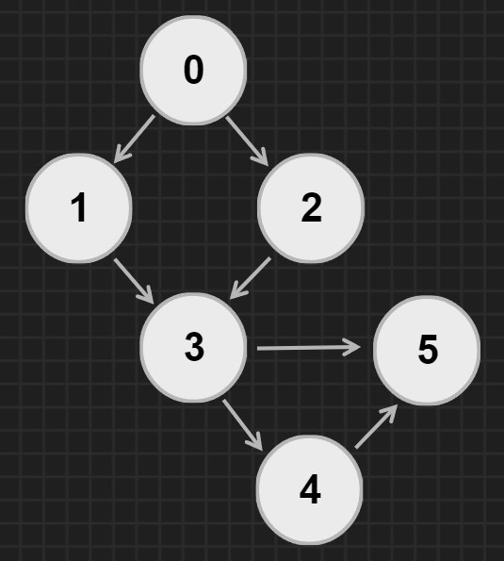

1. S= {(1,2), (1,5), (2,1), (2,3), (2,4), (2,5), (3,2), (3,4), (4,2), (4,3), (4,5), (5,1), (5,2), (5,4)}

|  |  |  |  |  |  |
| --- | --- | --- | --- | --- | --- |
|  | **1** | **2** | **3** | **4** | **5** |
| **1** | 0 | 1 | 0 | 0 | 1 |
| **2** | 1 | 0 | 1 | 1 | 1 |
| **3** | 0 | 1 | 0 | 1 | 0 |
| **4** | 0 | 1 | 1 | 0 | 1 |
| **5** | 1 | 1 | 0 | 1 | 0 |

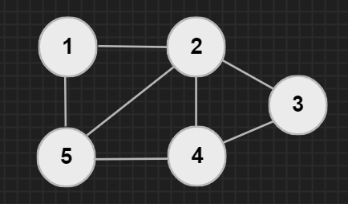

1. S = {(1,2), (1,4), (2,5), (3,5), (3,6), (4,2), (5,4), (6,6)}

|  |  |  |  |  |  |  |
| --- | --- | --- | --- | --- | --- | --- |
|  | **1** | **2** | **3** | **4** | **5** | **6** |
| **1** | 0 | 1 | 0 | 1 | 0 | 0 |
| **2** | 0 | 0 | 0 | 0 | 1 | 0 |
| **3** | 0 | 0 | 0 | 0 | 1 | 1 |
| **4** | 0 | 1 | 0 | 0 | 0 | 0 |
| **5** | 0 | 0 | 0 | 1 | 0 | 0 |
| **6** | 0 | 0 | 0 | 0 | 0 | 1 |

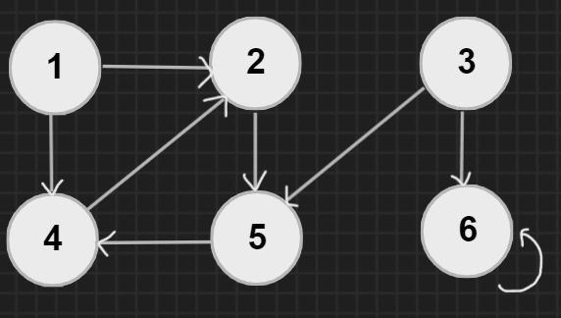

|  |  |  |  |  |  |
| --- | --- | --- | --- | --- | --- |
|  | **1** | **2** | **3** | **4** | **5** |
| **1** | 0 | 1 | 1 | 1 | 0 |
| **2** | 0 | 0 | 0 | 1 | 1 |
| **3** | 1 | 1 | 0 | 0 | 1 |
| **4** | 0 | 0 | 0 | 0 | 1 |
| **5** | 0 | 0 | 0 | 1 | 0 |

1. S = {(1,2), (1,3), (1,4), (2,4), (2,5), (3,1), (3,2), (3,5), (4,5), (5,4)}

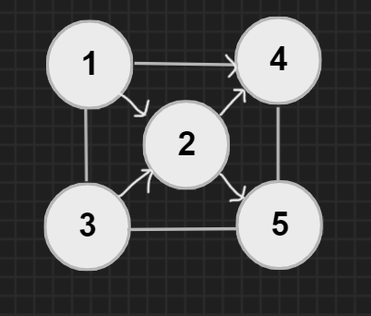

1. S = {(1,2), (2,1), (2,3), (2,4), (3,3), (4,1), (4,3), (5,6)}

|  |  |  |  |  |  |  |
| --- | --- | --- | --- | --- | --- | --- |
|  | **1** | **2** | **3** | **4** | **5** | **6** |
| **1** | 0 | 1 | 0 | 0 | 0 | 0 |
| **2** | 1 | 0 | 1 | 1 | 0 | 0 |
| **3** | 0 | 0 | 1 | 0 | 0 | 0 |
| **4** | 1 | 0 | 1 | 0 | 0 | 0 |
| **5** | 0 | 0 | 0 | 0 | 0 | 1 |
| **6** | 0 | 0 | 0 | 0 | 0 | 0 |

